Technical Research Report

The Evolution of AI Agents and Modern AI Engineering

Introduction
Artificial Intelligence (AI) has evolved from rule-based systems into intelligent applications powered by Large Language Models (LLMs). Modern AI systems can understand natural language, reason, use external tools, remember previous interactions, and complete multi-step tasks autonomously. This evolution has created the field of AI Engineering, which focuses on designing, deploying, and maintaining intelligent AI applications.

1. LLM Applications
Large Language Models (LLMs) are deep learning models trained on massive datasets to understand and generate human language.
Applications
- Chatbots and virtual assistants, Code generation, Content creation, Language translation, Document summarization, Customer support, Educational assistants
Real-World Examples
- ChatGPT, GitHub Copilot, Claude, Gemini

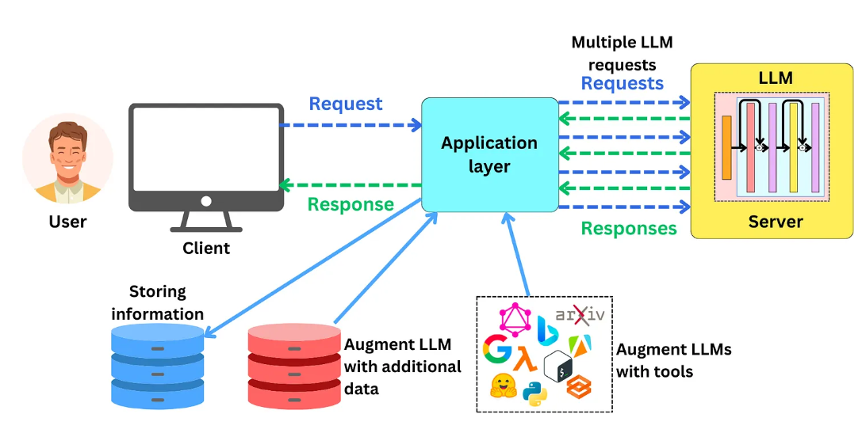2. AI Agents
An AI Agent combines an LLM with reasoning, memory, planning, and tool usage to perform tasks autonomously instead of only answering questions.
Capabilities
- Goal-oriented decision making, Multi-step reasoning, Tool integration, Context awareness, Autonomous execution
Example: A travel agent AI searches flights, compares hotels, creates an itinerary, and books reservations.

3. Tool Calling
Tool Calling allows an AI agent to access external services whenever additional information or computation is required.
Common Tools
- Web Search, Calculator, Weather API, Database, Email, Calendar
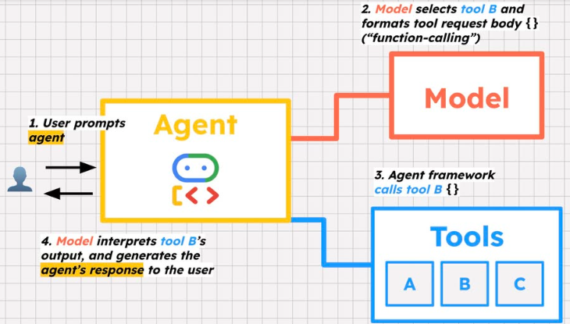
Example: When asked about tomorrow’s weather, the AI retrieves live data from a weather API before responding.

4. Memory
Memory enables AI agents to retain information and provide personalized responses.
- Short-Term Memory: Maintains the current conversation.
- Long-Term Memory: Stores user preferences and retrieves past information using databases or vector stores.
Memory improves personalization and reduces repetitive user input.

5. Planning
Planning allows AI agents to divide complex goals into smaller executable steps.
Example
Goal: Build an AI application
- Collect data
- Train model
- Test performance
- Deploy application
- Generate report
Planning improves efficiency and task completion.

6. Multi-Agent Systems
A Multi-Agent System (MAS) consists of several specialized AI agents working together under a coordinator.

Architecture
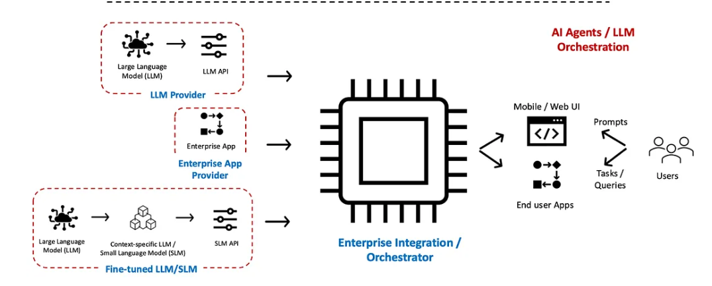
Applications
- Software development
- Customer support
- Healthcare
- Financial analysis

7. Future of AI Engineering
AI Engineering is moving toward autonomous, collaborative, and intelligent systems.
Future trends include:
- Agentic AI, Multi-Agent Systems, Retrieval-Augmented Generation (RAG), Long-term memory, AI software engineers, Cloud-native AI deployment, Responsible AI and security
Future AI engineers will require knowledge of LLMs, APIs, vector databases, cloud platforms, and AI deployment practices.

Conclusion
The evolution of AI has transformed language models into intelligent agents capable of reasoning, planning, remembering, and collaborating. Technologies such as Tool Calling, Memory, Planning, and Multi-Agent Systems are shaping the next generation of AI applications. As AI Engineering advances, these technologies will become the foundation of modern intelligent software.

References
- OpenAI API Documentation – https://platform.openai.com/docs
- Anthropic Documentation – https://docs.anthropic.com
- Google AI (Gemini) Documentation – https://ai.google.dev
- LangChain Documentation – https://python.langchain.com
- Russell, S., & Norvig, P. Artificial Intelligence: A Modern Approach (4th Edition).
- Goodfellow, I., Bengio, Y., & Courville, A. Deep Learning. MIT Press.

